Psuedo Code
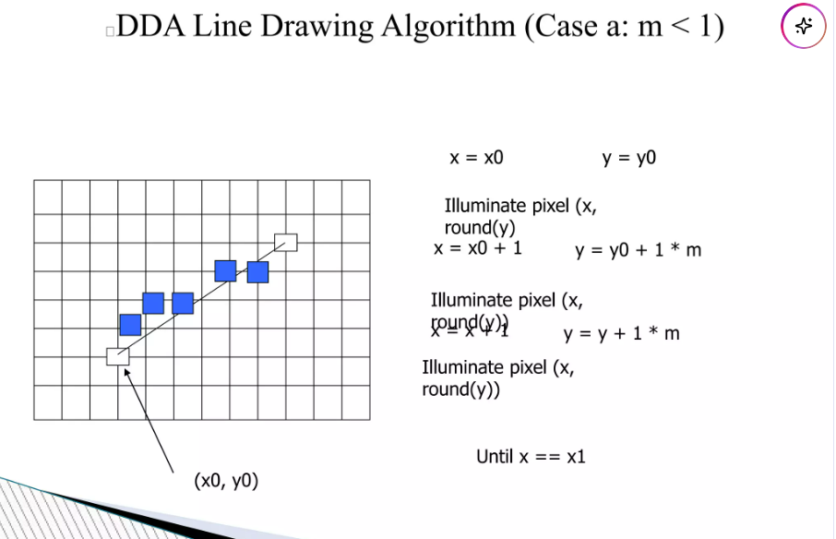
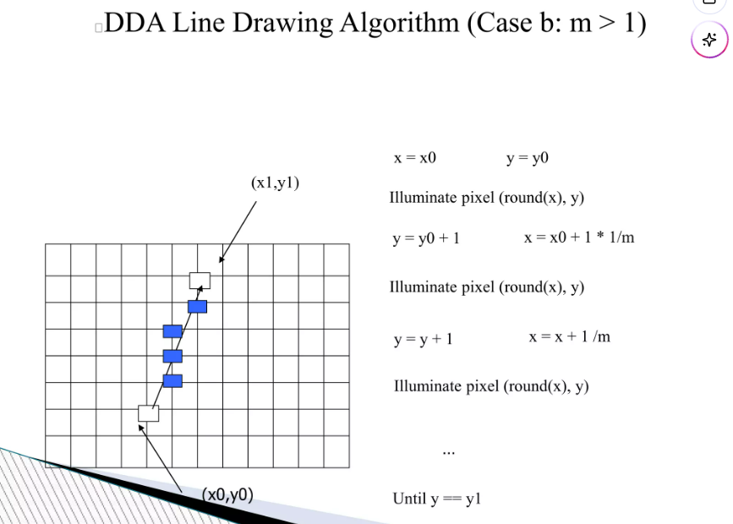
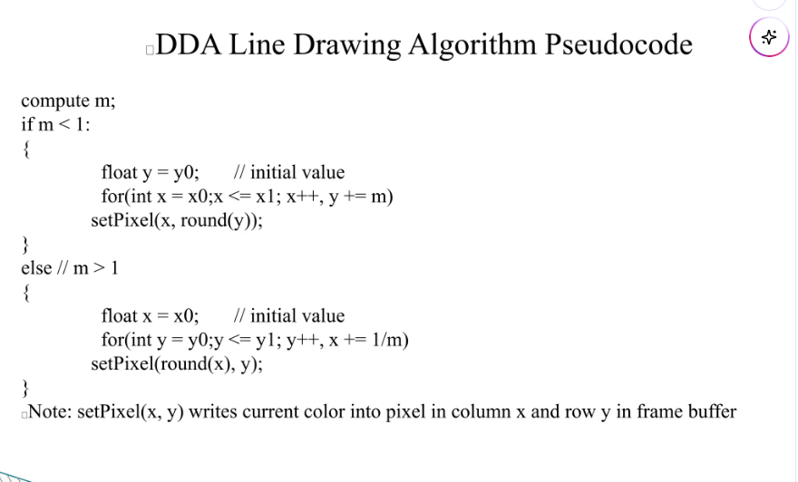
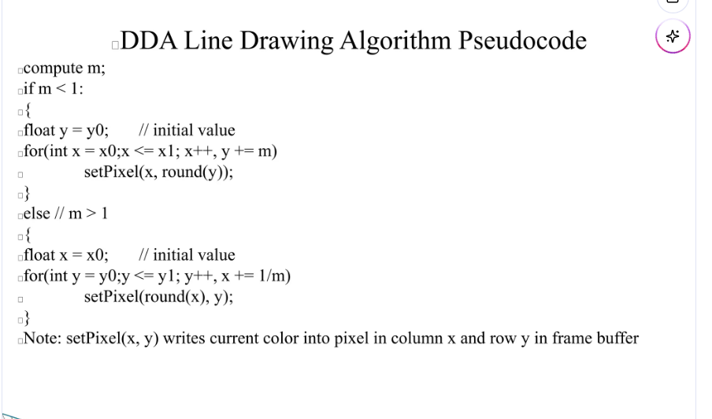

Tab 1
Cube Drawing using DDA Algorithm.
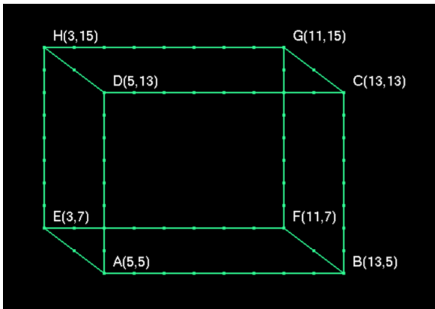
House Drawing using DDA Line Algorithm
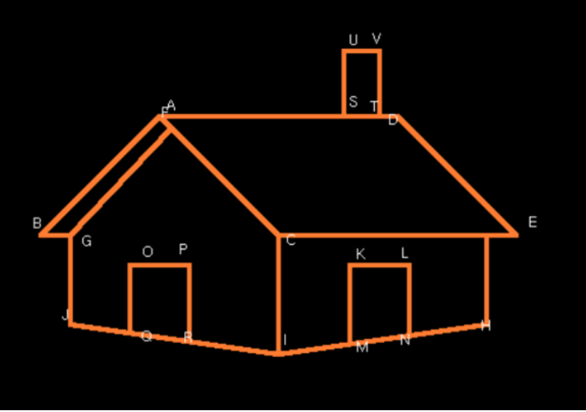

SUBMISSION LINK

code templete
from OpenGL.GL import *
from OpenGL.GLUT import *
from OpenGL.GLU import *

# DDA Algorithm implementation
def draw_dda(x1, y1, x2, y2):
dx = x2 - x1
dy = y2 - y1

# Calculate slope m
# Handling vertical lines to avoid division by zero
if dx == 0:
m = float('inf')
else:
m = dy / dx

if abs(m) < 1:
# Case 1: m < 1 (or equal)
# We step through X
if x1 > x2: # Ensure we draw from left to right
x1, y1, x2, y2 = x2, y2, x1, y1

y = float(y1)
for x in range(int(x1), int(x2)):
set_pixel(x, round(y))
y += m
else:
# Case 2: m > 1
# We step through Y
if y1 > y2: # Ensure we draw from bottom to top
x1, y1, x2, y2 = x2, y2, x1, y1

x = float(x1)
for y in range(int(y1), int(y2)):
set_pixel(round(x), y)
x += (1/m)

# Function to draw a pixel
def set_pixel(x, y):
glBegin(GL_POINTS)
glVertex2i(int(x), int(y))
glEnd()

def display():
glClear(GL_COLOR_BUFFER_BIT)
glColor3f(1.0, 1.0, 1.0) # White line

# Example coordinates
draw_dda(100, 100, 400, 100)
glFlush()

def iterate():
glClearColor(0.0, 0.0, 0.0, 1.0) # Black background
glViewport(0, 0, 500, 500)
glMatrixMode(GL_PROJECTION)
glLoadIdentity()
glOrtho(0.0, 500, 0.0, 500, 0.0, 1.0)

glutInit()
glutInitDisplayMode(GLUT_SINGLE | GLUT_RGB)
glutInitWindowSize(500, 500)
glutInitWindowPosition(100, 100)
glutCreateWindow(b"DDA Line Drawing Algorithm")

iterate()
glutDisplayFunc(display)
glutMainLoop()

